Exp 15.3
Develop a program to accept usrname and password
//Client form

<html>
<head>
</head>
<body><form name=form1 method=get action="http://localhost:8080/salunkhe/servlet/GenericServletDemo">
Name: <input type=text name=user1 value="">
Password: <input type=text name=password1 value="">
<input type=submit value="login">
<input type=reset value="reset">
</form>
</body>
</html>

//servlet

import java.io.*;
import javax.servlet.*;
public class GenericServletDemo extends GenericServlet
{
public void service(ServletRequest request ,ServletResponse response) throws ServletException,IOException
{
response.setContentType("text/html");
PrintWriter out=response.getWriter();
out.println("<HTML>");
out.println("<HEAD><TITLE>hello page</TITLE></HEAD>");
out.println("<BODY>");
String name=(String) request.getParameter("user1");
String password=(String) request.getParameter("password1");
out.println("Name="+name+"<br>");
out.println("Passsword="+password+"<br>");
out.println("</BODY></HTML>");
}
}

web.xml

<web-app>
<servlet>
<servlet-name>GenericServletDemo</servlet-name>
<servlet-class>GenericServletDemo</servlet-class>
</servlet>
<servlet-mapping>
<servlet-name>GenericServletDemo</servlet-name>
<url-pattern>/servlet/GenericServletDemo</url-pattern>
</servlet-mapping>
</web-app>

Output:

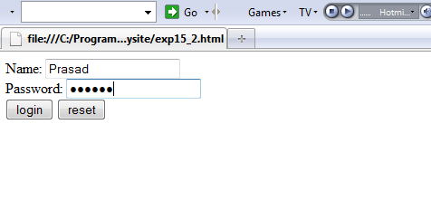

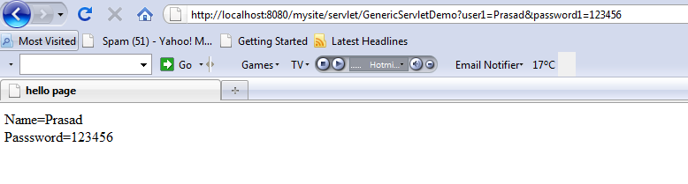

Exp 15.4
Develop a program to authenticate the user name and password
//Client form

<html>
<head>
</head>
<body>
<form name=form1 method=post action="http://localhost:8080/mysite/servlet/GenericServletDemo2">
Username: <input type=text name=user1 value=""><br>
Password: <input type=text name=password1 value=""><br>
<input type=submit value="login">
<input type=reset value="reset">
</form>
</body>
</html>
//servlet

import java.io.*;
import javax.servlet.*;
public class GenericServletDemo2 extends GenericServlet
{
public void service(ServletRequest request ,ServletResponse response)

throws ServletException,IOException
{
String uname="Prasad";
String pass="123456";
response.setContentType("text/html");
PrintWriter out=response.getWriter();
out.println("<HTML>");
out.println("<HEAD><TITLE>hello page</TITLE><HEAD>");
out.println("<BODY>");
String name=(String) request.getParameter("user1");
String password=(String) request.getParameter("password1");
if((name.equals(uname))&&(password.equals(pass)))
{
out.println("Welcome "+name);
}
else
{
out.println("Invalid username or password");
}
out.println("</BODY></HTML>");
}
}

Output:

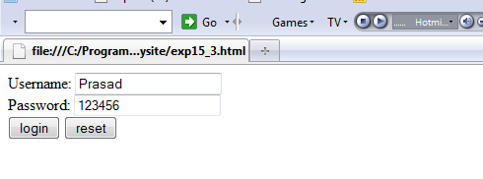
When Valid user

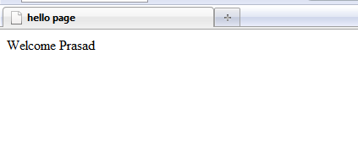
When Invalid User

