EXPERIMENT NO: 5

a. Write a program for demonstration of Generic Servlets.

Theory
GenericServlet class implements Servlet, ServletConfig and Serializable interfaces. It provides the implementaion of all the methods of these interfaces except the service method.
GenericServlet class can handle any type of request so it is protocol-independent.
You may create a generic servlet by inheriting the GenericServlet class and providing the implementation of the service method.

Methods of GenericServlet class
There are many methods in GenericServlet class. They are as follows:
- public void init(ServletConfig config) is used to initialize the servlet.
- public abstract void service(ServletRequest request, ServletResponse response) provides service for the incoming request. It is invoked at each time when user requests for a servlet.
- public void destroy() is invoked only once throughout the life cycle and indicates that servlet is being destroyed.
- public ServletConfig getServletConfig() returns the object of ServletConfig.
- public String getServletInfo() returns information about servlet such as writer, copyright, version etc.
- public void init() it is a convenient method for the servlet programmers, now there is no need to call super.init(config)
- public ServletContext getServletContext() returns the object of ServletContext.
- public String getInitParameter(String name) returns the parameter value for the given parameter name.
- public Enumeration getInitParameterNames() returns all the parameters defined in the web.xml file.
- public String getServletName() returns the name of the servlet object.
- public void log(String msg) writes the given message in the servlet log file.
- public void log(String msg,Throwable t) writes the explanatory message in the servlet log file and a stack trace.

Example on GenericServlet
Develop a program to authenticate the user name and password
//Client form

<html>
<head>
</head>
<body>
<form name=form1 method=post action="http://localhost:8080/mysite/servlet/GenericServletDemo2">
Username: <input type=text name=user1 value=""><br>
Password: <input type=text name=password1 value=""><br>
<input type=submit value="login">
<input type=reset value="reset">
</form>
</body>
</html>
//servlet

import java.io.*;
import javax.servlet.*;
public class GenericServletDemo2 extends GenericServlet
{
public void service(ServletRequest request ,ServletResponse response)
throws ServletException,IOException
{
String uname="Prasad";
String pass="123456";
response.setContentType("text/html");
PrintWriter out=response.getWriter();
out.println("<HTML>");
out.println("<HEAD><TITLE>hello page</TITLE><HEAD>");
out.println("<BODY>");
String name=(String) request.getParameter("user1");
String password=(String) request.getParameter("password1");
if((name.equals(uname))&&(password.equals(pass)))
{
out.println("Welcome "+name);
}
else
{
out.println("Invalid username or password");
}
out.println("</BODY></HTML>");
}
}

Output:

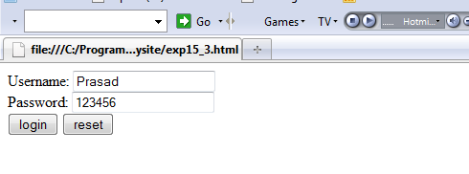
When Valid user

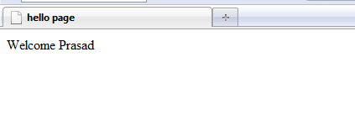
When Invalid User

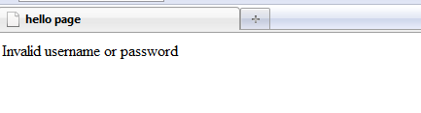

b. Write a program for demonstration of HTTP Servlets.

HttpServlet class

The HttpServlet class extends the GenericServlet class and implements Serializable interface. It provides http specific methods such as doGet, doPost, doHead, doTrace etc.

Methods of HttpServlet class
There are many methods in HttpServlet class. They are as follows:
- public void service(ServletRequest req,ServletResponse res) dispatches the request to the protected service method by converting the request and response object into http type.
- protected void service(HttpServletRequest req, HttpServletResponse res) receives the request from the service method, and dispatches the request to the doXXX() method depending on the incoming http request type.
- protected void doGet(HttpServletRequest req, HttpServletResponse res) handles the GET request. It is invoked by the web container.
- protected void doPost(HttpServletRequest req, HttpServletResponse res) handles the POST request. It is invoked by the web container.
- protected void doHead(HttpServletRequest req, HttpServletResponse res) handles the HEAD request. It is invoked by the web container.
- protected void doOptions(HttpServletRequest req, HttpServletResponse res) handles the OPTIONS request. It is invoked by the web container.
- protected void doPut(HttpServletRequest req, HttpServletResponse res) handles the PUT request. It is invoked by the web container.
- protected void doTrace(HttpServletRequest req, HttpServletResponse res) handles the TRACE request. It is invoked by the web container.
- protected void doDelete(HttpServletRequest req, HttpServletResponse res) handles the DELETE request. It is invoked by the web container.
- protected long getLastModified(HttpServletRequest req) returns the time when HttpServletRequest was last modified since midnight January 1, 1970 GMT.

Example

Develop a program to retrieve user’s data
HTML File - GetUserData.html
<html>
<body>
<center>
<form name="Form1" method=get action="http://localhost:8080/mysite/servlet/ GetUserData">
<B>Student Details:</B>
<BR/>
<table>
<tr>
<td><B>Student Roll No.:</td>
<td><input type=textbox name="roll" size="25" value=""></td>
</tr>
<tr>
<td><B>Student Name:</td>
<td><input type=textbox name="name" size="25" value=""></td>
</tr>
</table>
<input type=submit value="Submit">
</form>
</body>
</html>

Servlet File - GetUserData.java
import java.io.*;
import javax.servlet.*;
import javax.servlet.http.*;
public class GetUserData extends HttpServlet
{
public void doGet(HttpServletRequest request, HttpServletResponse response)throws IOException, ServletException
{
String roll = request.getParameter("roll");
String name = request.getParameter("name");
response.setContentType("text/html");
PrintWriter pw = response.getWriter();
pw.println("<B>Student Roll No.: ");
pw.println(roll);
pw.println("<BR>");
pw.println("<B>Student Name: ");
pw.println(name);
pw.close();
}
}
Output:

